- What are the functions of life, as demonstrated by all living organisms?

- Define the following terms, with examples:
Unicellular

Multicellular

Acellular

- Why are viruses often considered non-living?

- Outline the three fundamental statements of cell theory
i.

ii.

iii.

- What is the significance of the discoveries made by Antonie van Leeuwenhoek and Robert Hooke?

- For many years, scientists thought that new organisms came about through ‘spontaneous generation’. Outline the idea of spontaneous generation and the experiments carried out by Pasteur and Remak to refute this idea.

- Some types of cell seem to break the laws of cell theory.
a. Give two examples of cells which are multinucleated

b. Why are viruses often considered ‘acellular’ or even non-living?

- Complete this table of SI units of length:
Unit | Abbreviation | Metric Equivalent  Whole scientific notation
kilometer | km | 1 000 m | 10³ m
 | m | 1 m | -
centimeter | cm |  | 10⁻² m
 | mm | 0.001 m | 10⁻³ m
micrometer | μm | 0.000 001 m
nanometer | nm |  | - m

- The diagram below shows the characteristic rod-shaped structure of E. coli bacteria.
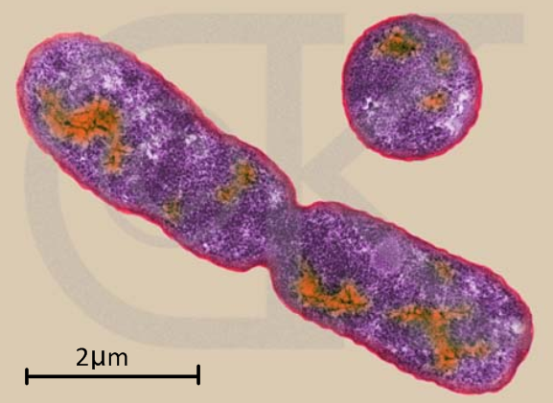
a. What is the magnification of the image?

b. By which method (shown here) do bacteria
reproduce?

- What is the actual size of the structures delineated in yellow?
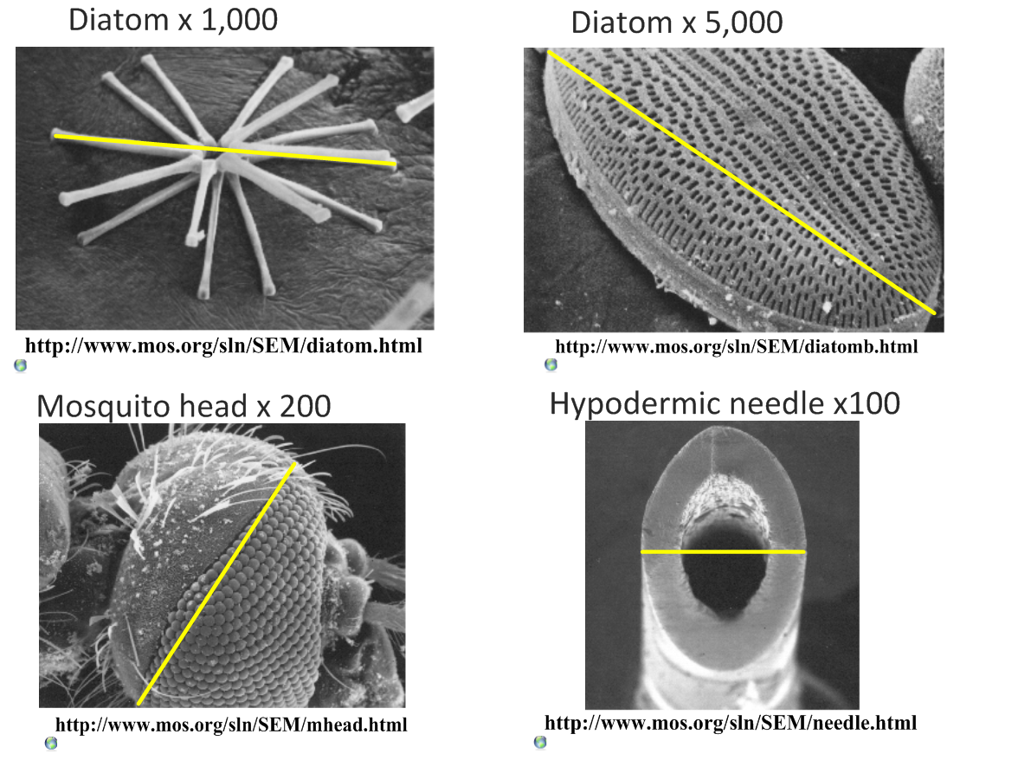

- Calculate the magnification of these scale bars:
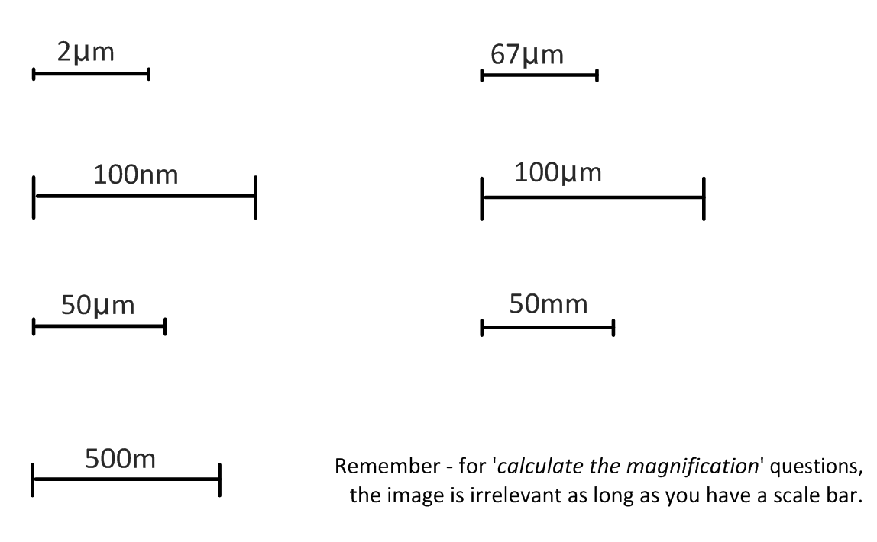
- What is the magnification of these images?

- Scale bar 10µm measures 40mm on the image.

b. Scale bar 5µm measures 25mm on the image.

- A micrograph has a scale bar of 2µm, which measures 40mm on the image. Measuring the maximum length of the cell in the image, the ruler reads 180mm. How long is the cell?

- A student views an image of a cell magnified 350 times. The image is 250mm long. What is the actual length of the sample in the image?

- Compare the sizes of these structures. Use SI units.

Plant cell | Animal cell | nucleus | bacteria | Mito-chondria | virus | ribosome | Membrane thickness | molecules

- Use some of these electron microscope resources to view molecules, cells and structures and to practice calculating magnifications and actual sizes.

Virtual Electron Microscope: http://virtual.itg.uiuc.edu/

Microscopy UK: http://www.microscopy-uk.org.uk/

- As the volume of a cell increases, what happens to…? (increase/ decrease)

- Production of waste products.

- Usage of nutrients and oxygen.

- The surface area: volume ratio.

- What are the advantages of maximizing the surface area: volume ratio in a cell?

- What strategies do cells use to maintain an efficient SA:Vol?

- What are some of the ways in which larger organisms maximize SA:Vol?

- How can a large SA:Vol be harmful or costly to smaller animal species?

- How does the invasive Caulerpa algae genus break the rules of SA:Vol?

- Read this article: Giant bacterium with many genomes
http://scienceblogs.com/notrocketscience/2008/04/enormous_bacterium_uses_thousands_of_genome_copies_to_its_ad.php

How does this bacterium cope with being so large?

- Unicellular organisms carry out all the functions of life, multi-cellular organisms differentiate and show emergent properties.

- What is meant by the term emergent properties?

- What are the advantages of cells differentiating to carry out specific functions?

- All cells in a living organism carry the same genetic information.
  - What is a stem cell?

  - What are the following types of stem cells?

Pluripotent

Multipotent

Nullipotent

  - What type of cell can a liver stem cell become?

- Outline the process of cell differentiation that leads from an uncommitted stem cell to a specialized cell, including the role of gene expression. A flow chart might help.

- Give three examples of specialized cells in multicellular organisms. Describe how their structure relates to their function.

i.

ii.

iii.

- Complete the table below to show how stem cells can be used in medicine.

 | Therapeutic cloning | Stem cell transplants
Used to treat
Brief method:
Ethical considerations

Reading:
Stem cells cure sickle cell anemia in mice:
http://medgadget.com/archives/2007/12/scientists_cure_sickle_cell_anemia_in_mouse_model.html

10 amazing medical breakthroughs (read them all):
http://www.time.com/time/specials/2008/top10/article/0,30583,1855948_1863993,00.html

iPS Stem cells used to make human neurons:
http://scienceblogs.com/notrocketscience/2008/08/stem_cells_created_from_als_patient_and_used_to_make_neurons.php

- What are the objections of some groups to the use of embryonic stem cells?

- How might iPS stem cell technology reduce the need for embryonic stem cells?

