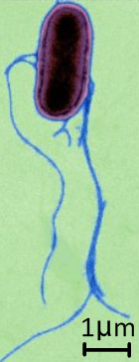
- This is an electronmicrograph of the bacterium Salmonella typhi.

a. What is the maximum length of the main body of the cell?

b. What are the name and function of this structure?

- S typhi and E. coli are examples of prokaryotes.
What does the term ‘prokaryote’ literally mean?

- In the space below, draw and label (with names and functions), the structure of a generalized prokaryote cell. Include cell wall, plasma membrane, pili, flagella, nucleoid (naked DNA), ribosomes and a scale bar.

- Distinguish between gram-positive and gram-negative bacteria.

- Through which method do prokaryotes divide and reproduce?

- Which structures can you identify in this diagram and EM image?
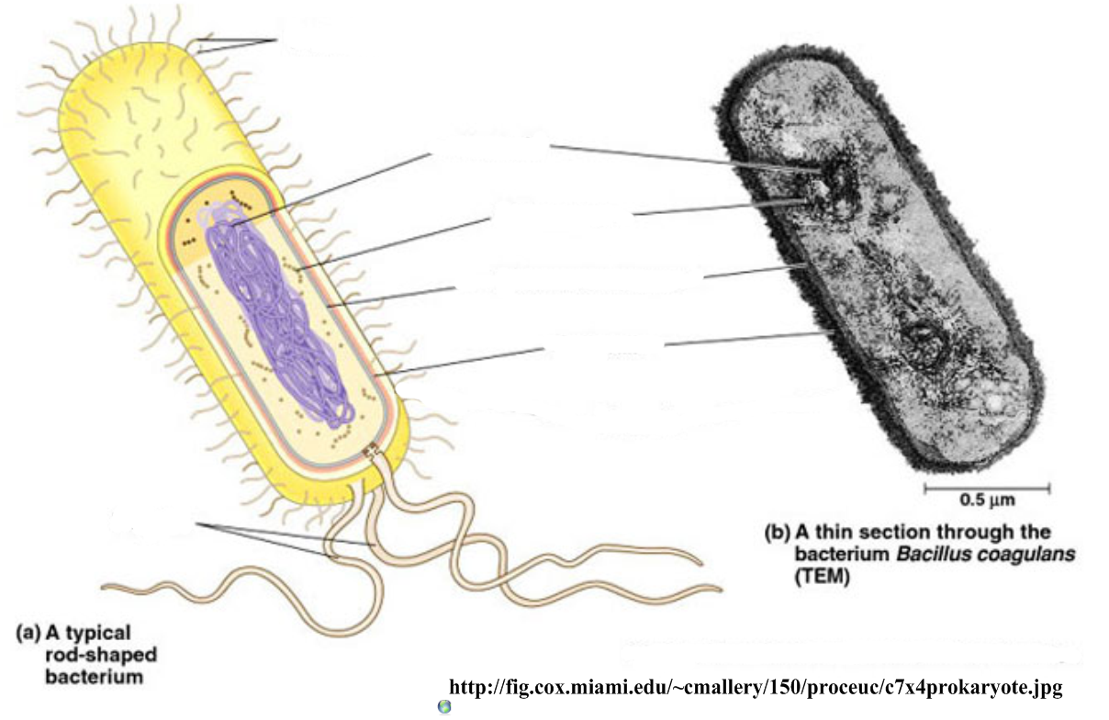

- Name the labeled structures in this transmission electronmicrograph:
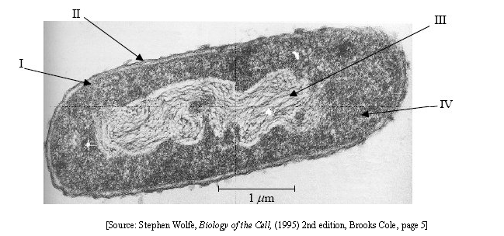
- Calculate the magnification of the above image and the maximum length of the bacterium.

