Sources to use: Allott text (p34-35), Click4Biology, Class presentations, The Habitable Planet (http://www.learner.org/courses/envsci/)
- Define taxonomy.

- In the table below, list the seven levels in the hierarchy of taxa and design an acronym to help you remember them. Using two examples from different kingdoms give all seven levels.

 | Hierarchical level | ACRONYM | PLANT Example: | ANIMAL Example:
Most  diverse | Kingdom
Most
Specific
Most  Specific | species

- Define species.

- In the space below, explain how the Linnean binomial system of nomenclature works, paying attention to formatting conventions.
Eschericia coli

E. coli

Homo sapiens

- Distinguish between heterotrophy and autotrophy. Which feeding method is represented by the Kingdom Plantae and which by the Kingdom Animalia?

- Distinguish between the following phyla of plants, using external characteristics. Give examples.
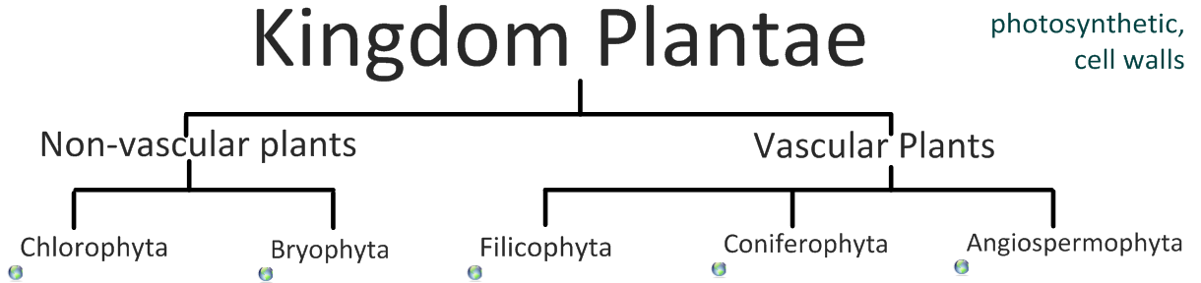
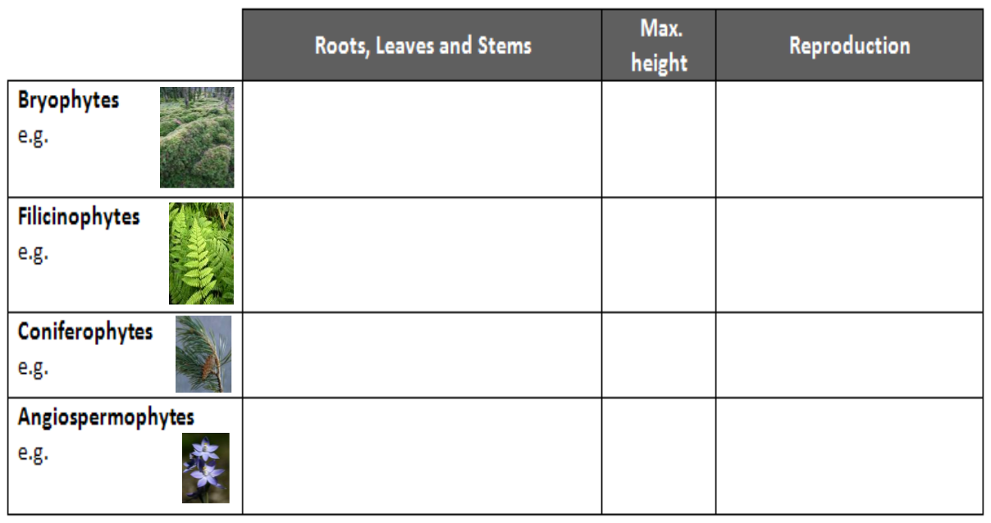

- Have a go at using a dichotomous key here: http://www.scenicoregon.com/webanic/pages/animals.html
Take the opportunity to build your vocabulary while completing this task.
Think of an animal, answer the questions and work through the classification.

- Distinguish between the following phyla of animals, using external recognition features and giving examples. Check your answers here: http://www.scenicoregon.com/webanic/pages/map.html
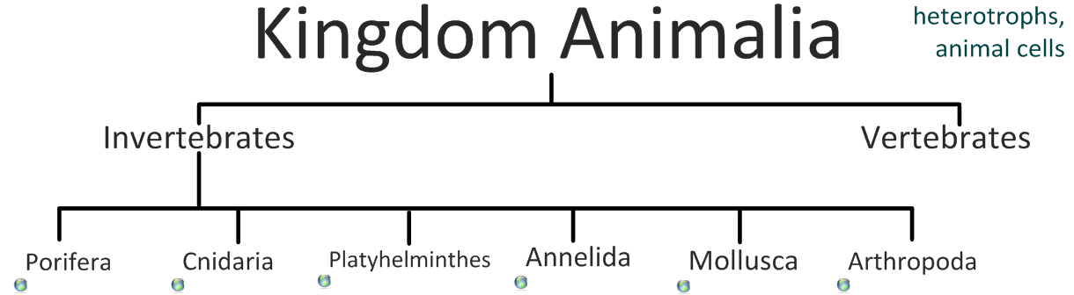
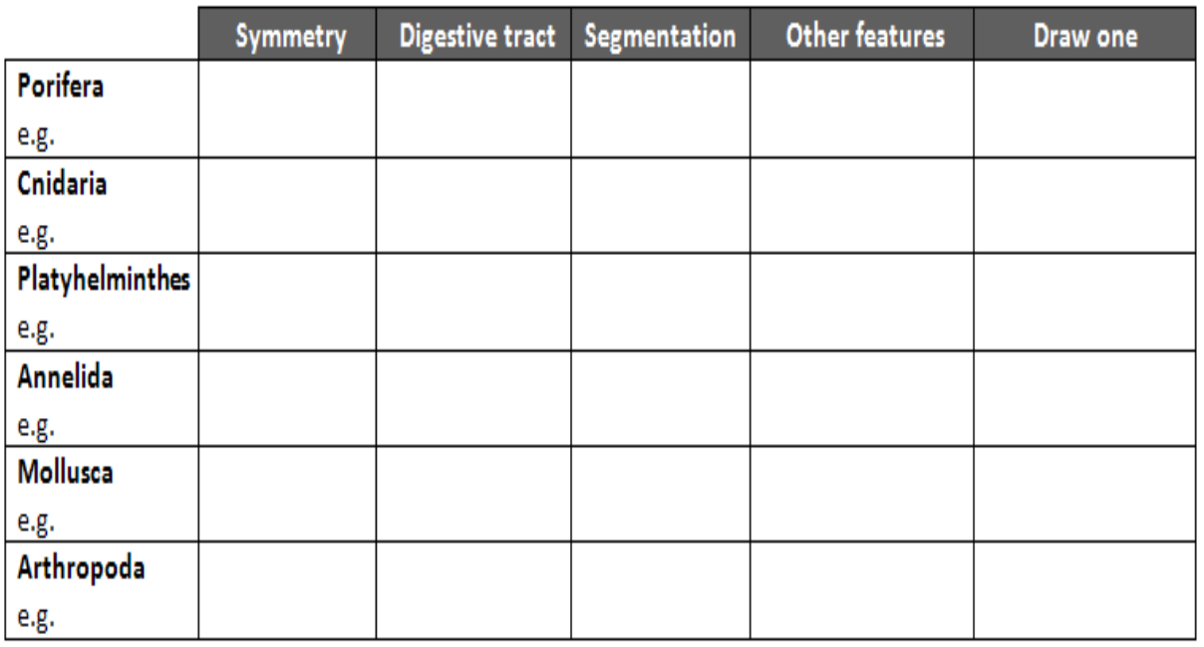

- Distinguish between these terms:
Radial symmetry vs Bilateral symmetry vs Asymmetrical

Motile vs Sessile
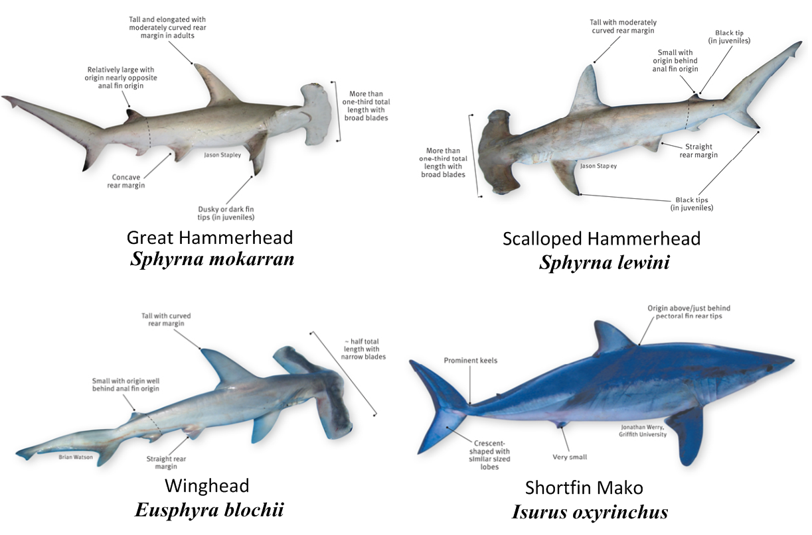
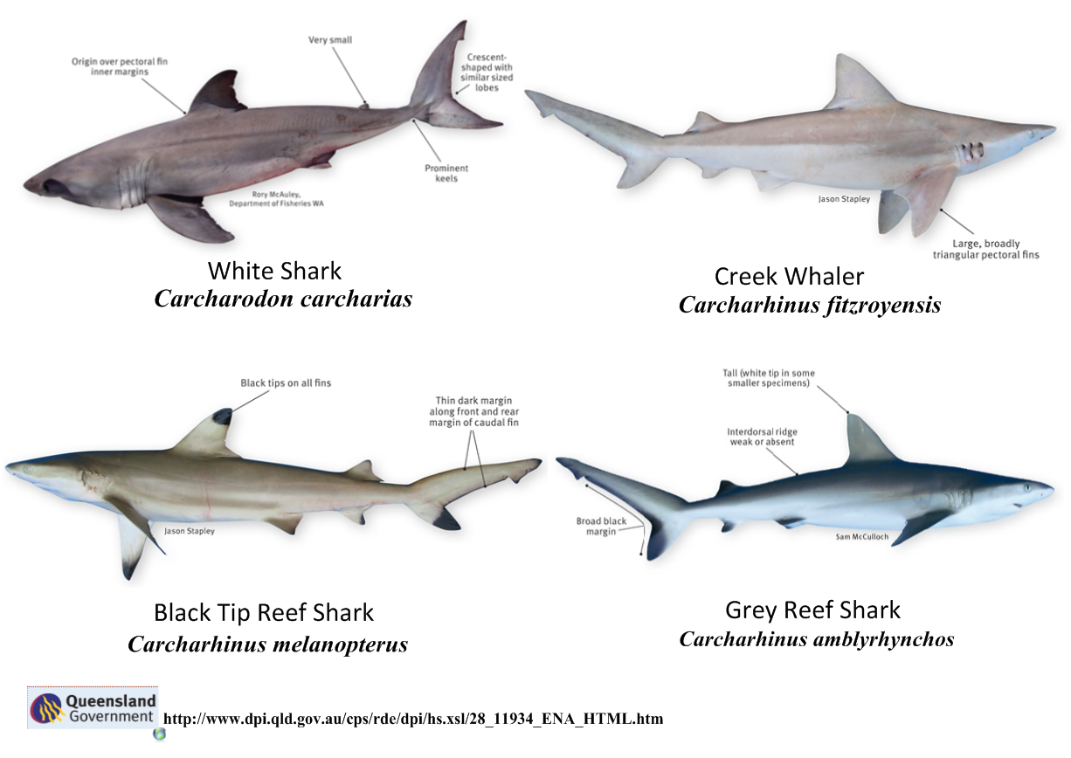
- Design and apply a dichotomous key to distinguish between these Queensland shark species:
- Look at the species names for the sharks in the chart.
  - Which of the following pairs is most closely related?
    - Black Tip Reef Shark and White Shark
    - Grey Reef Shark and Shortfin Mako
    - Grey Reef Shark and Winghead
    - Creek Whaler and Black Tip Reef Shark

  - Explain your answer to a.

  - Which of the following is/are true for the Great Hammerhead and Scalloped Hammerhead?
- They are two subspecies of the same species
ii. They are two species in the same genus
iii. They are members of the same order
iv. They are from different phyla
    - i only
    - i and ii
    - ii and iii
    - iv only

  - Which of the following is/are true of all of the sharks in the chart?
- They are members of the same species
      - They are part of the same genus
      - They are part of the same class
      - They are part of the same kingdom
    - i only
    - i and ii
    - ii and iii
    - iii and iv

