1. Draw and label a simplified (2D) diagram of the plasma membrane.

Include: phospholipid bilayer, integral and peripheral proteins, glycoproteins and cholesterol.

Why is it described as a bilayer?

1. What are the general functions of the plasma membrane?
2. What is the plasma membrane described as a *fluid mosaic model*?
3. What are the functions of these plasma membrane components?
4. glycoproteins
5. cholesterol
6. Match the following *membrane proteins* with their functions:

Channel/ carrier proteins used in cell surface reactions

Protein pumps binding cells together

Receptor proteins communication between cells

Enzymes passive transport across the membrane

Adhesion proteins active transport across the membrane

Neurotransmitter receptors hormone binding and recognition

1. Draw a single phospholipid molecule. Label the *hydrophobic* and *hydrophilic* sections.
2. Explain how hydrophobic and hydrophilic properties of the phospholipid bilayer allow a membrane to maintain its structure.
3. Define *selectively permeable* in the context of the plasma membrane.
4. Define *diffusion*.

Define *osmosis*.

1. Distinguish between *solute, solvent* and *solution*.
2. State four ways to **maximize the rate of diffusion** of a substance across a membrane.

a.

b.

c.

d.

1. In the table below, **tick the conditions required** for each type of transport to occur.

|  |  |  |  |  |
| --- | --- | --- | --- | --- |
|  | Concentration gradient | Selectively permeable membrane. | Membrane proteins | ATP (source of energy) |
| Simple diffusion |  |  |  |  |
| Osmosis |  |  |  |  |
| Facilitated diffusion |  |  |  |  |
| Active transport |  |  |  |  |

1. By which method does each of the following types of molecules travel across a membrane?

Water

Non-polar molecules *(with the concentration gradient)*

Polar molecules *(with the concentration gradient)*

Any molecule *against* the concentration gradient

Macromolecules

1. Explain what is happening in this diagram:

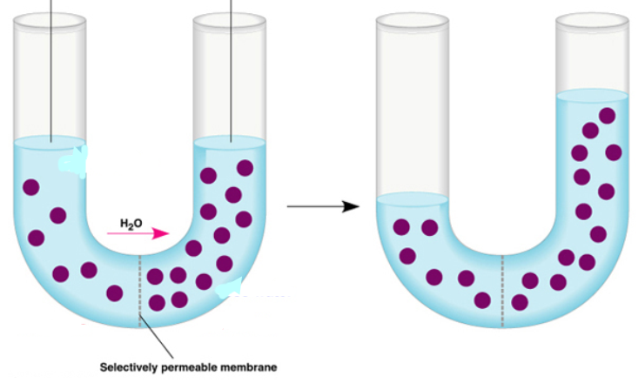

1. In the space below, draw a diagram of a cell before and after plasmolysis.

Explain how osmosis causes plasmolysis.

1. ATP is the source of energy for active transport. Explain how ATP releases energy, using a simple diagram.
2. Distinguish between *uniport*, *symport* and *antiport* as different methods of active transport. A simple diagram of each will help.
3. Annotate the diagram below to show how a *protein pump* is used in active transport of molecules across a plasma membrane. The Na+/K+ pump is an example.

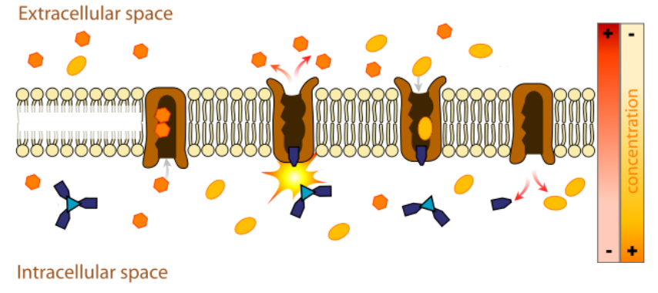

1. What is a *macromolecule*? Give one example of a macromolecule produced in the cell.
2. What is a *vesicle*?
3. What might happen to proteins produced by the cell, or to antibodies, without the use of vesicles?
4. Complete and annotate the diagram below to show the process of vesicle transport of a protein molecule through a eukaryote cell. Begin with protein synthesis in the Rough ER and finish with *exocytosis though the plasma membrane*. Label all organelles shown.

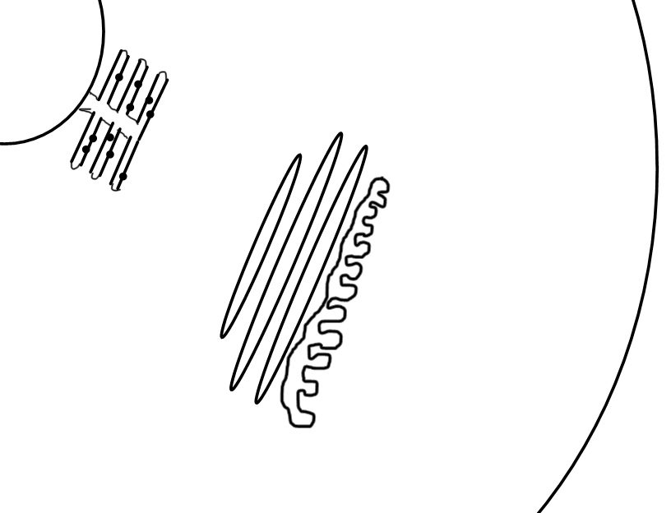

1. Differentiate between *exocytosis* and *endocytosis*.
2. Describe how the plasma membrane breaks and reforms during exocytosis and endocytosis. How does the fluidity of the membrane allow this?

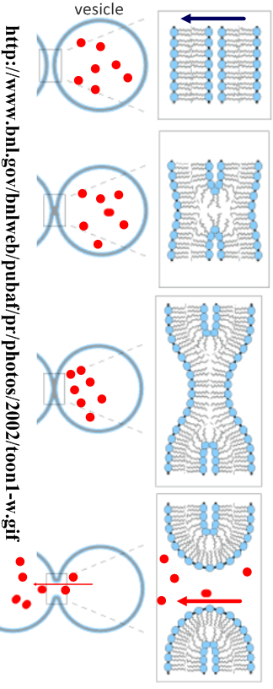

1. A study was carried out to determine the relationship between the diameter of a molecule and its movement through a membrane. The graph below shows the results of the study.



[Source: Knox, *et al., Biology,* Mcgraw Hill, Sydney, 1994, page 65]

(a) From the information in the graph alone, describe the relationship between the diameter of a molecule and its movement through a membrane.

.........................................................................................................................................

.........................................................................................................................................

.........................................................................................................................................

.........................................................................................................................................

**(2)**

A second study was carried out to investigate the effect of passive protein channels on the movement of glucose into cells. The graph below shows the rate of uptake of glucose into erythrocytes by simple diffusion and facilitated diffusion.



(b) Identify the rate of glucose uptake at an external glucose concentration of 4 mmol dm-3by

(i) simple diffusion. .........................................

**(1)**

(ii) facilitated diffusion. .........................................

**(1)**

(c) (i) Compare the effect of increasing the external glucose concentration on glucose uptake by facilitated diffusion and by simple diffusion.

...............................................................................................................................

...............................................................................................................................

...............................................................................................................................

...............................................................................................................................

...............................................................................................................................

...............................................................................................................................

**(3)**

(ii) Predict, with a reason, the effect on glucose uptake by facilitated diffusion of increasing the external concentration of glucose to 30 mmol dm-3.

...............................................................................................................................

...............................................................................................................................

...............................................................................................................................

...............................................................................................................................

**(2)**

**(Total 9 marks)**